**Report for COVID-19 Simulation project**

Team 1

Lou Liu 001000382

Yue Fang 001584481

Zongduo Li 001096123

* **Task**

Simulate the spread of a virus such as SARS-CoV-2, the pathogen behind COVID-19 and show the simulation progress in GUI.

Also make simulation which can contrast SARS-CoV-2 with another pathogen (SARS).

Document and chart the results of the simulations.

* **Conclusion**

**SARS-CoV-2 seems likely to spread explosively.**

**When contrast to SARS，the spread of SARS-CoV-2 is faster than SARS and it begins more quicker. And when simulation stopped, the total number of infection and epidemic areas of SARS-CoV-2 are both larger than SARS’s.**

If people wear mask, government sets quarantine area and tests, and contracts trace of infect people, all these methods can slow down the spread.

* **Evidence to support**
  + **Assumptions and Factors**

Assumptions we make:

* In the GUI Canvas, each block represents individual area (maybe unit in city) and it will contain different population density, flow speed of people moving out and head count in total as well.
* The darker colour means more infections in particular area.
* Also, we randomly set some area to be quarantine, these areas will not let people from other area to flow in, so these areas keep healthy in the whole simulation.

According to research of the k/R factors:

* k-factor we used for SARS-CoV-2 is 0.5 and 0.86 for SARS
* R0-factor we used for SARS-CoV-2 is 3.8 and 1.2 for SARS

We calculate spread speed as following formula:

Speed = mask factor * test&trace factor * current infection num * population density * R0 / k

And the spread speed will be re-calculate after the infection number changed.

* + **Simulation screenshots**

**Single Simulation:**

|  |  |
| --- | --- |
| People in beginning epidemic area is obeyed to wear mask (keep other factors same) | People in beginning epidemic area do not wear mask (keep other factors same) |
|  |  |
| The total infection number is larger when people do not wear mask, which help the virus spreading. | |
|  |  |
| At last, the total number of epidemic areas is larger when people do not wear mask. | |

**Multiple Simulation (SARS-CoV-2 vs SARS):**

|  |  |
| --- | --- |
|  | When the begin area is set to quarantine, the number of infections will not grow in that area and the virus will not spread to other area in the whole map (canvas). |
|  | When given the same beginning area (with same population density and other behaviors), SARS-CoV-2 will spread slower than SARS.  Also, with more restriction actions (wearing mask/doing test and contact tracing), the spread will be slower. |
|  |

|  |  |
| --- | --- |
| Following charts are the infection population and epidemic areas in the same simulation of SARS-CoV-2 and SARS. | |
|  |  |
|  |  |
| The beginning time to spread of SARS-CoV-2 is earlier than SARS’s, SARS-CoV-2’s total number of infections is larger and SARS-CoV-2’s epidemic areas are more than SARS’s. | |

* **Walk Through**

|  |  |
| --- | --- |
| 1. run ***MainJFrame*** to get the GUI Frame   （src/main/java/UserInterface/MainJFrame） |  |
| 2. Choose ***Single Pathegon Simulation*** or ***Multiple Pathogens Simulation*** to get into simulation mode |  |
| 3. Enter the ***Population Density*** textbox with number (better to larger than 5000); check boxes to set some factors that attribute to the random area to begin spread the virus (if ***Quarantine*** is 'yes', the infection will not go outside that origin area) |  |
| 4. Click on ***Start Simulation*** and there will be a random-selected area as the beginning epidemic area, then canvas will show the progress of simulation |  |
| 5. After the simulation stop, there are several charts to view using ***See ALL Reports***, select the time of simulation to see details report charts; Click on the ***Show in Explorer*** will open the picture in system |  |
| 6. ***Back*** button take back from the report view page to simulation page |  |

* **Screenshot of Unit test passing**

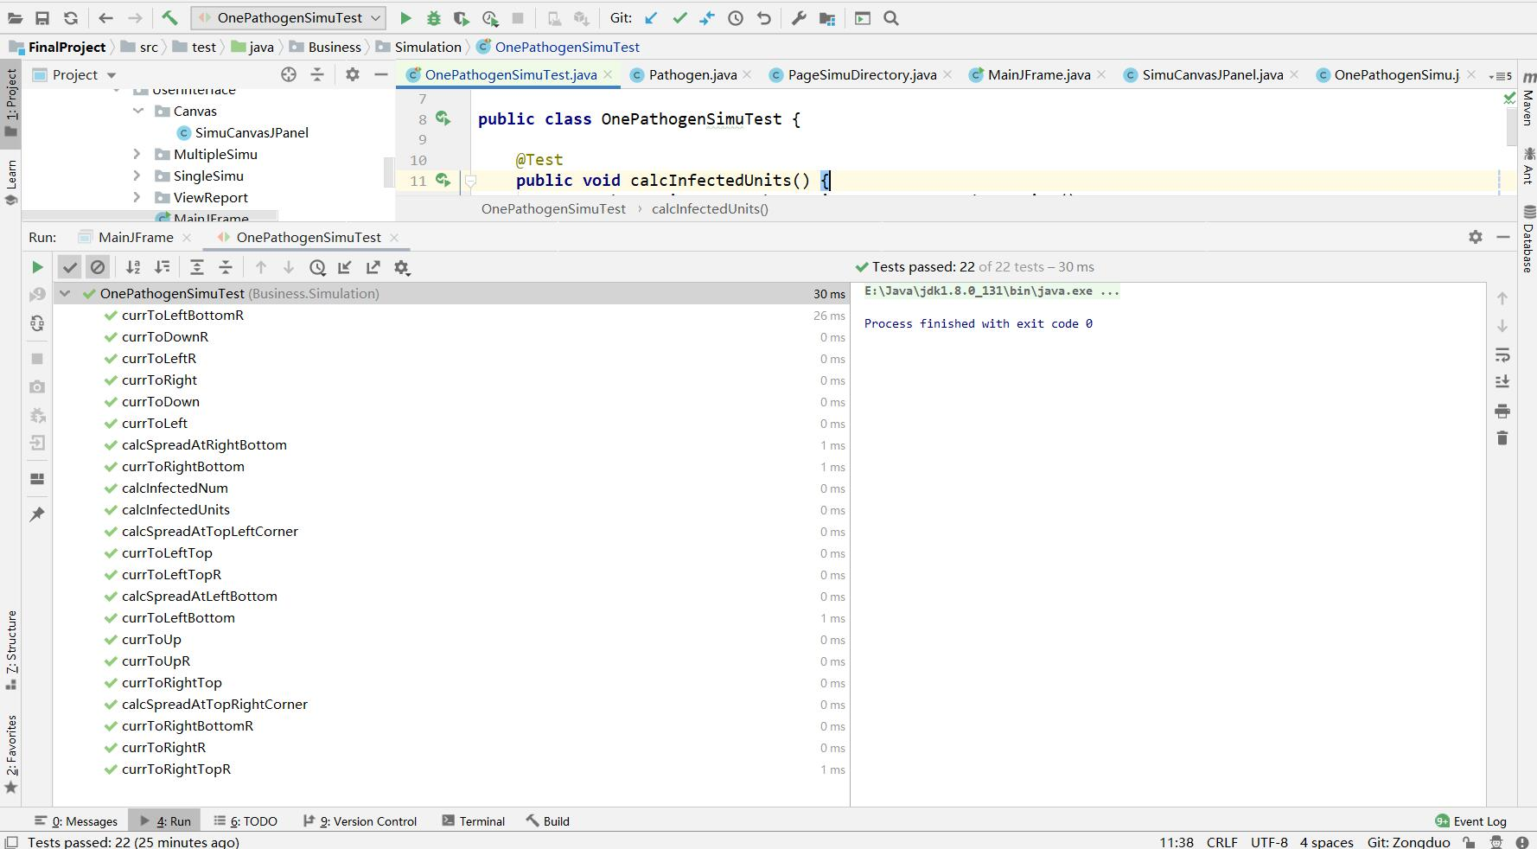

* **Reference**

<https://www.upsbatterycenter.com/blog/super-spreading-and-k-factors-of-dispersion/>

<https://en.wikipedia.org/wiki/Basic_reproduction_number>

<https://www.sciencefocus.com/news/the-k-factor-nevermind-r-heres-the-number-we-need-to-understand/>

<https://www.upsbatterycenter.com/blog/super-spreading-and-k-factors-of-dispersion/>

<https://www.who.int/news/item/23-01-2020-statement-on-the-meeting-of-the-international-health-regulations-(2005)-emergency-committee-regarding-the-outbreak-of-novel-coronavirus-(2019-ncov)>